**ASSIGNMENT 1 – ADVANCED PROGRAMMING**

**Exploring Open Source Software**

**NAME: MALIK HASSAN RAZA REG NO.: 208046 CLASS: BSCS 7B**

**Introduction**

Prestashop is an open source ecommerce platform that allows you to configure, setup and maintain an ecommerce store easily and efficiently. It not only helps you manage products on your store but also helps you manage finances, payments, orders and deliveries. It is developed in PHP and provides a fully responsive interface for customers and managers both. Its basic features are free to use, provide support for multiple payment gateways, has been translated into multiple languages and is highly customize able. You can setup your store without even having any programming background.

**Installation and Configuration**

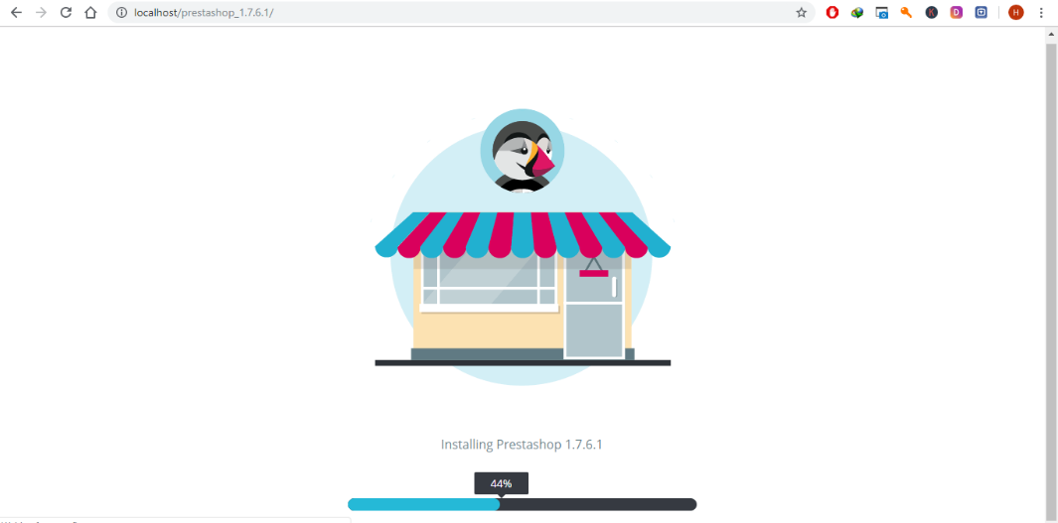First of all I downloaded “Prestashop 1.7.6.1” from its official website and moved the zip file to “htdocs” directory of xampp server to put it on my local server. I unzipped the file and accessed it from the browser window and installation wizard started.

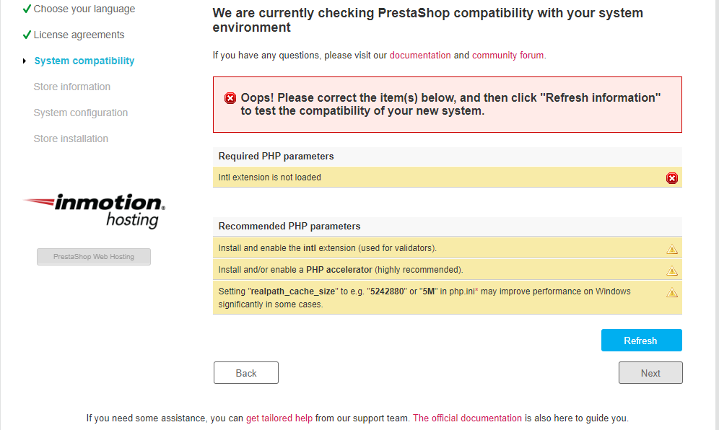I configured basic store settings like Language selection, License Agreement.

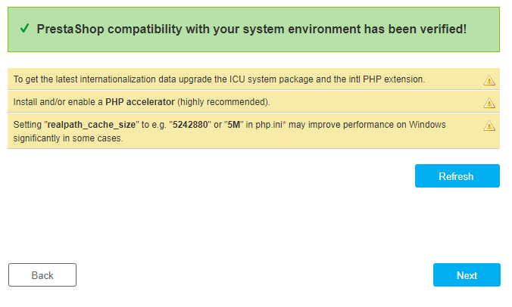During system compatibility check an error showed up that “Intl extension is not loaded”. I looked it up using stack overflow and solved the problem by editing “php.ini” file. I removed semicolon from the front of “;extension=php_intl.dll” and refreshed. In this way I solved this problem by getting help from developer community one of the main advantage of open source software that you find solutions to the problems in the developers community.

Now actual configuration of the store started. I started with a store named “Devspecial”. It asks you for basic information about store like store name, your target niche, country, time zone and admin panel details like name, email and password.

In the system configuration part it asks you to provide credentials to establish a connection to database server like database server address, database name, username, password and table prefix. If the database does not already exists you have to create it. I created a database named “prestashop” using phpmyadmin. And established connection. After database connection has been established and store installation finished I realized that almost 250 of tables were created in the database.

**Exploring Prestashop**

After installation user must delete “install” folder from the server to access the admin panel of the store. When user logs in for the first time it gives you a tour automatically to help user get familiar with the application and get started.

It shows you a progress bar to help you launch your store. User just has to complete task to launch store which basically includes adding product, payment gateway, shipping costs and taxation details (if any).

User has a menu bar on left side which consist of two main sections “SELL” and “IMPROVE”.

**SELL**

This section includes following options

1. Orders

It allows you to manage orders and shopping cart, generate invoices, credit slips, delivery slips.

1. Catalog

This section gives you options to manage stock, vendors, discounts, products and categories. It also allows you to customize attributes and features of products.

1. Customers

It simply help you build and manage a list of customers.

1. Customer Service

Helps user manage order messages and merchandise returns.

1. Stats

Provides user with reports, stats and forecasts.

**IMPROVE**

This section includes following options

1. Shipping

Allow user to manage shipping companies and set preferences.

1. Module

Allows user to manage modules and add new modules to add additional functionality to the store.

1. Design

Allows user to manage and set themes, add widgets and perform image settings.

1. Payment

User can set payment methods and gateways using this option

1. International

It allows you manage taxation, languages and locations.

**Database and coding structure**

As far as the coding structure of Prestashop is concerned it uses a 3-tier architecture. It is similar to MVC architecture and has many advantages. It works on the same principle of Model>View>Controller but in a more simpler, efficient and accessible way. It is easy to read code written in a software based on 3-tier architecture. It allows developer to edit and write code faster. A developer does not need to know about other parts of the software. He/She can write independent code.

But this tier 3 architecture was used in Presetashop until its version 1.6. In version 1.7(which I happen to use here) and onwards it was decided to incorporate Symfony PHP framework to make code more robust, modular and fully testable. They finally decided to use a globally recognized stable framework so that they can focus on core functionality.

There are three possible customizations in Prestashop which are following

1. Themes
2. Modules
3. Overriding

A store manager can develop his/her own theme or module or chose to use a theme/module from prestashop marketplace where a number of themes and modules are available for free. A user must be familiar with the concepts of PHP and OOP (Object Oriented Programming) before attempting to write custom modules in prestashop.

Prestashop uses a really complex relational database to store data. All the tables in the database start by a prefix “ps_” by default. All the tables in the database have names in lowercase and words are separated by “_”.

When a link is created between two entities the name of connecting entities are mentioned in the table name. For example: ps_category_product. More details about it can be found in the documentation file.

**Modules**

A number of modules are available in prestashop which can be added to add customize funcationality to your store. I added “ps_checkpayment” in my online store. I allows you to take payment via check. Once you install it, you have to configure it. The configuration in case of this module is pretty simple and straightforward. You just have to add “Payee Name” and “Address” and you are done.